Nucleic acid is isolated from the nuclei of pus cells for the 1st time by
A. Friedrich Miescher
B. Hook
C. Brown
D. Singer
ANSWER: A
The basic unit of nucleic acid is:
A. Nucleotide
B. Amino acid
C. Terpenes
D. Monosaccharide
ANSWER: A
Formation of nucleotide takes place in _______
A. One Step
B. Two Step
C. Three Step
D. Four Step
ANSWER: B
There are _______ kinds of nucleic acids
A. 1
B. 2
C. 3
D. 4
ANSWER: B
Nucleic acids are:
A. Macromolecules
B. Micromolecules
C. Monomer
D. Molecule
ANSWER: A
Which of the following is a monomer of nucleic acid?
A. Monosaccharide
B. Amino acid
C. Fatty acid
D. Nucleotides
ANSWER: D
If the sugar is__________, the polymer is RNA
A. Ribose
B. Deoxyribose
C. Both A and B
D. None of these
ANSWER: A
If the sugar is __________, the polymer is DNA
A. Ribose
B. Deoxyribose
C. Both A and B
D. None of these
ANSWER: B
__________ are naturally occurring chemical compounds that serve as the primary information-carrying molecules in cells and make up the genetic material
A. Carbohydrates
B. Proteins
C. Lipids
D. Nucleic acids
ANSWER: D
Nucleic acid was first discovered in
A. 1869
B. 1598
C. 1489
D. 1894
ANSWER: A
DNA is present in:
A. Cytoplasm
B. Nucleolus
C. Chromatin of the cell nucleus
D. Membrane
ANSWER: C
Most of the RNA is found in:
A. Cell cytoplasm
B. Nucleolus
C. Chromatin of the cell nucleus
D. Membrane
ANSWER: A
A nucleotide is composed of _________ distinctive chemical sub-units
A. One
B. Two
C. Three
D. Four
ANSWER: C
_________ are organic molecules consisting of a nucleoside and a phosphate
A. Amino acid
B. Monosaccharide
C. Nucleotides
D. Protein
ANSWER: C
Nucleotides serve as _________of the nucleic acid polymers
A. Polymeric units
B. Monomeric units
C. Macro units
D. All of these
ANSWER: B
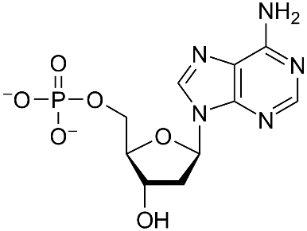
The structure above is a:
A. Amino acid
B. Monosaccharide
C. Nucleotide
D. Protein
ANSWER: C
A nucleotide is a molecule that consists of:
A. Pentose sugar
B. Nitrogenous base
C. Phosphoric acid
D. All of these
ANSWER: D
What is the composition of nucleoside?
A. A sugar + a phosphate
B. A base + a sugar
C. A base + a phosphate
D. A base + a sugar + phosphate
ANSWER: B
What is the composition of a nucleotide?
A. A sugar + a phosphate
B. A base + a sugar
C. A base + a phosphate
D. A base + a sugar + phosphate
ANSWER: D
The sugar molecule in a nucleotide is:
A. Pentose
B. Hexose
C. Tetrose
D. Triose
ANSWER: A
Group of adjacent nucleotides are joined by:
A. Phosphodiester bond
B. Peptide bond
C. Ionic bond
D. Covalent bond
ANSWER: A
Building blocks of nucleic acids are:
A. Nucleotide
B. Nucleosides
C. Amino acids
D. Histones
ANSWER: A
There are ___________ basic types of nitrogenous bases
A. 1
B. 2
C. 3
D. 4
ANSWER: B
_______________ include two nitrogenous bases named adenine and guanine
A. Pyrimidine
B. Purine
C. Both Pyrimidine and Purine
D. None of these
ANSWER: B
_________includes three nitrogenous bases cytosine, thymine and uracil
A. Purine
B. Pentose
C. Pyrimidine
D. None of these
ANSWER: C
The four nucleobases in __________are guanine, adenine, cytosine and thymine
A. RNA
B. DNA
C. mRNA
D. tRNA
ANSWER: B
In__________, uracil is used in place of thymine
A. RNA
B. DNA
C. Deoxyribonucleic acid
D. All of these
ANSWER: A
Identify the purine base of nucleic acids in the following.
A. Cytosine
B. Thymine
C. Uracil
D. Adenine
ANSWER: D
Which of the following is not the components of RNA?
A. Thymine
B. Adenine
C. Guanine
D. Cytosine
ANSWER: A
The number of hydrogen bonds between adenine and thymine?
A. 1
B. 2
C. 3
D. 4
ANSWER: B
_______ occurs only in DNA
A. Uracil
B. Thymine
C. Guanine
D. Adenine
ANSWER: B
If the sugar is__________, the polymer is RNA
A. Ribose
B. Deoxyribose
C. Both A and B
D. None of these
ANSWER: A
Purine includes:
A. Adenine, Guanine
B. Thymine, Cytosine
C. Uracil, Adenine
D. Thymine, Guanine
ANSWER: A
Pyrimidine includes:
A. Thymine, Guanine
B. Uracil, Adenine
C. Thymine, Cytosine, Uracil
D. None of these
ANSWER: C
If the sugar is __________, the polymer is DNA
A. Ribose
B. Deoxyribose
C. Both A and B
D. None of these
ANSWER: B
__________ discovered that nucleic acids were composed of five nitrogenous bases
A. Friedrich Miescher
B. Albrecht Kossel
C. Albert von kölliker
D. Louis pasture
ANSWER: B
One of the most important molecules found in living organisms is ATP. What is its major function?
A. Energy currency of the cell
B. Coenzyme
C. Cofactor
D. Both A and B
ANSWER: A
ATP stands for:
A. Adenine triphosphate
B. Adenosine triphosphate
C. Both A and B
D. None of these
ANSWER: B
The structure of ATP includes:
A. Adenine
B. Ribose
C. Phosphate
D. All of these
ANSWER: D
Ribose in the structure of ATP is a:
A. Three carbon sugar
B. Four carbon sugar
C. Five carbon sugar
D. Six carbon sugar
ANSWER: C
As the phosphate bond breaks the energy is:
A. Stored
B. Released
C. Utilized
D. None of these
ANSWER: B
ATP is a:
A. Mononucleotide
B. Dinucleotide
C. Polynucleotide
D. None of these
ANSWER: A
The breaking of one phosphate group bond releases about:
A. 6.3 kcal/mole
B. 7.3 kcal/mole
C. 5.3 kcal/mole
D. 9.3 kcal/mole
ANSWER: B
From which bonds of ATP molecule is energy taken?
A. P~P bonds
B. C~H bonds
C. C~N bonds
D. C~O bonds
ANSWER: A
NAD is a:
A. Mononucleotide
B. Dinucleotide
C. Polynucleotide
D. None of these
ANSWER: B
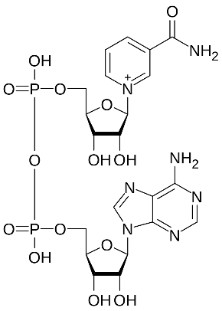
Identify the structure:
A. ATP
B. NAD
C. DNA
D. RNA
ANSWER: B

